Homepage –

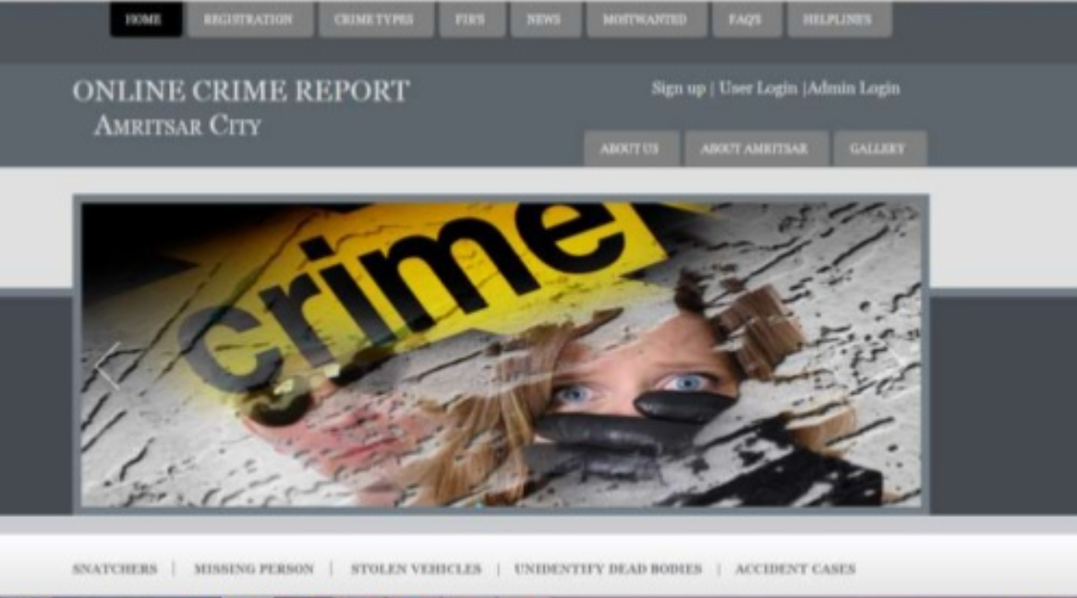

Number of cases solved today Number of cases registered today/ Safety tip

Gallery/ Covid awareness

2. Most wanted, helpline, missing persons, unidentified dead bodies

Login

Crime Types

News

Home

Cases Solved:

Remaining:

Safety Tip:

Quick Links/

Covid-Warriors

Footer - Social Media links/ developed by/ Maintained by

3.

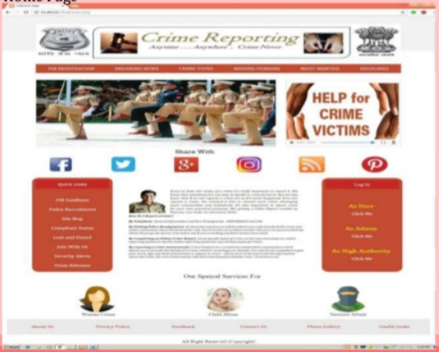

News –

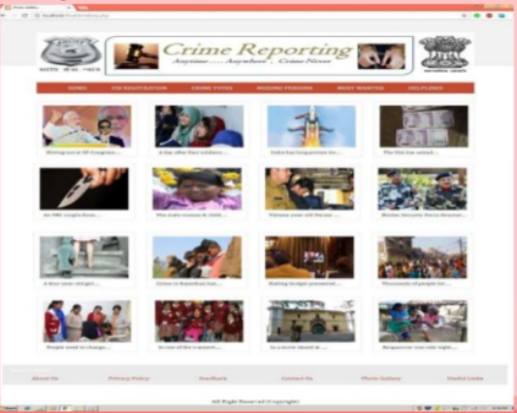

Crime Types:

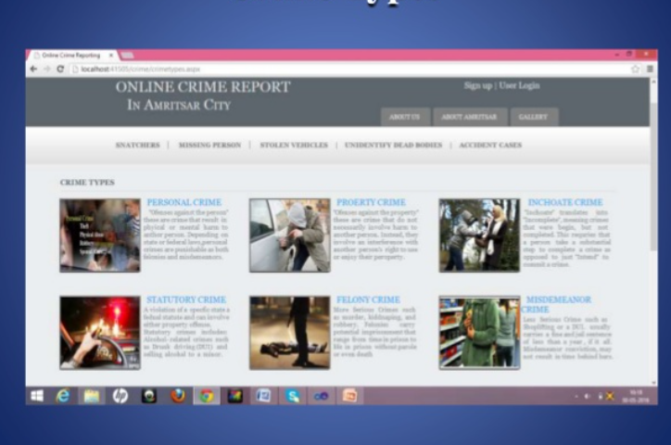

Missing Persons –

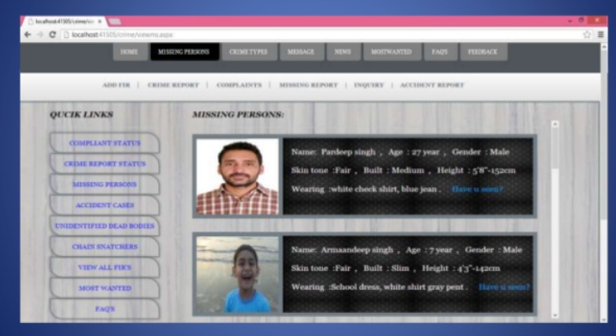

Most Wanted –

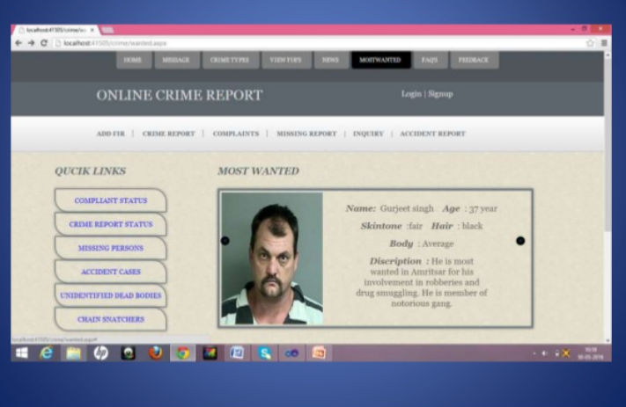

Login –

E-mail

Password

Next Page

Message - OTP has been sent to you on your registered mobile number.

OTP :

Next Page – Homepage with complaint and track complaint option.

Link to signup page

Login

Password

Next

OTP has been sent to your registered mobile number.

OTP:

Verify

Complaint

Track Complaint

Cases Solved:

Remaining:

Register –

Full Name:

Email-id

Birth Date

Mobile number

Pword

Identity card upload

Next Page–

OTP has been sent.

OTP –

Next Page - Homepage with complaint and track complaint option.

Police Login Page –

Login

Password

Captcha

Login

Complaint Page –

<https://www.jotform.com/form-templates/online-complaint-form-2>

Crime Type Select

Captcha

Or

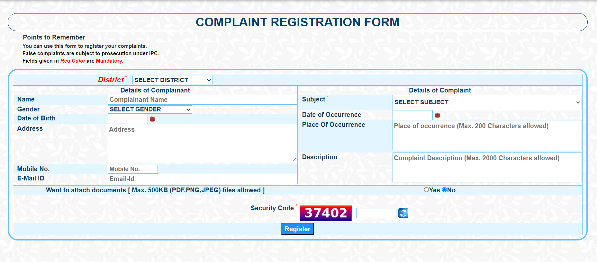

Track Complaint –

